Order Of Service

Singing: Psalm 66—CW page 90

Reading: Psalm 131

Opening Hymn: CW 282

Reading: James 2:1-13

Request Hymn: CW Supplement 735

Reading: Luke 18:31-43

Sermon Hymn: CW 260

Sermon Text: Song Of Solomon 1:14

Camphire In The Vineyards

Prayer

The Apostles’ Creed, TLH page 12

Holy Communion

The Lord's Prayer

The Blessing

Closing Hymn: CW 245

* * * * * * * * * * *

Bible Study: Lambs: Exodus 3:1-10; A Special Job
Sheep: Proverbs 5:1-6; Your Choice
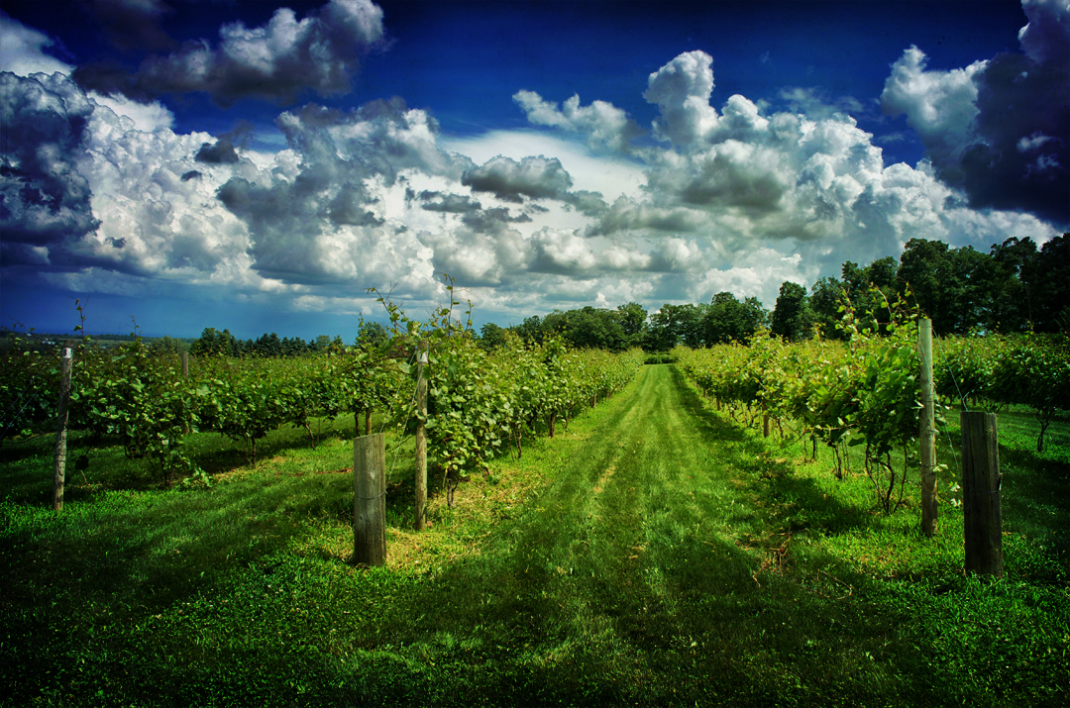

In The Vineyards

Water
Of
Life

13 September 2015

W A T E R O F L I F E

Independent Christian Church—Conservative Lutheran Doctrine

Worship Service: 9:30 a.m. Bible Study: 10:45 a.m.

Larry Cooper, Pastor E-Mail address:
111 N. Ridge Road lcooper@wateroflife.cc
Coon Valley, WI 54623 Web Site:
Phone: (608) 452-2105 www.wateroflife.cc

* * * * * * * * * * * * * * * * * * * * * * * * * * *

Sermon Text: Song Of Solomon 1:14

Camphire In The Vineyards

* * * * * * * * * * * * * * * * * * * * * * * * * * *
Song of Solomon 1:14 My beloved is unto me as a cluster of camphire in the vineyards of Engedi.

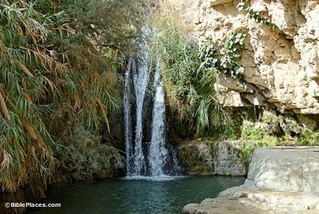
Engedi

This morning the Holy Spirit directs our attention to the region of Engedi. In his Old Testament Bible History Alfred Edersheim writes concerning Engedi, which was surrounded by desert wilderness, [There we see] “’the fountain of the goat,’ which, leaping down a considerable height in a thin cascade, converts that desert into the most lovely oasis.” [It unfolds into] “a scene of tropical beauty and wealth . . . such as it is scarcely possible to describe.”

“Bounded by two perennial streams, between which the Engedi itself makes its way, it must of old have been a little paradise; the plain covered with palm-trees, the slopes up the mountains with the choicest vineyards of Judea, scented with camphire. Song of Solomon 1:14.”

“But all above was ‘wilderness’, bare round limestone hills rising from two hundred to four hundred feet, burrowed by numberless caves, to which the entrance is sometimes almost inaccessible.” It was in this area that David escaped from king Saul by hiding in a cave.

